1. Wood carving

Sri Lanka, which is famous for handicrafts, holds a long history of craft heritage. According to “Mahawamsa” the prevailed arts and crafts were innovated with the arrival of Buddhist Nun “Sanghamitta” to Sri Lanka from India. The history records that crafts men belong to sixty different castes arrived to Sri Lanka along with her on her visit that brought the Sacred Bo- Tree to Anuradhapura.

With this heritage Sri Lanka got fame all over the world for its arts and crafts. If you visit ancient cities like Anuradgapura. Polonnaruwa, Sigiriya, Kandy you will marvel at the intricate designs of Sri Lankan craftsmen.

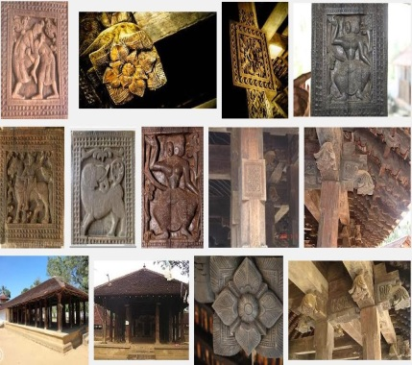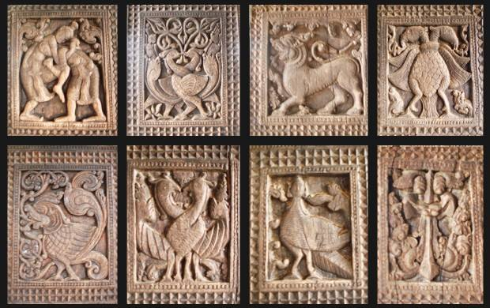Ambekke Devalaya is another marvelous place that you must visit on your visit to Sri Lanka. It’s located in Kandy district. The intricate wood carvings at the devalaya are stupendous in their beauty and designs. Still there are traditional carpenters who are engaged in wood carving. They create those age old master pieces. But the problem is that you will not be able to see them everywhere. For that you have now got a chance to see how those alluring creations are begot.

(youtube link ekak danna)

The mask industry can be mentioned as another aspect that shows the uniqueness of Sri Lanka's wood carving art. At a time when the people worshipped trees and animals, masks were an indispensable part of Sri Lankan rituals and ceremonies. Now centuries later they are more of an interesting oddity. However, the traditional mask industry is still a thriving business that continues to fascinate both locals and tourists alike. With their colourful facades, odd shapes and intriguing histories, traditional Sri Lankan masks are commonly found adorning the walls of local houses. They also make excellent souvenirs. All masks have grotesque features that make them all the more interesting. Most masks feature gaping, misshapen mouths; sinister, bulging eyes; and bright, vivid colours. The local masks can be divided into several categories depending on their uses.

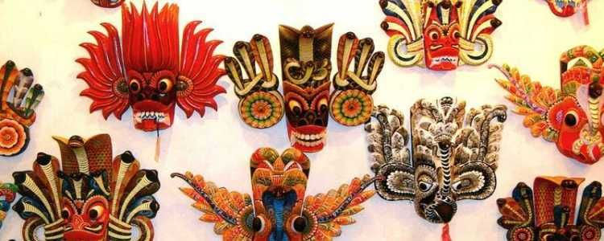

Some masks are used during ancestor worship, certain spiritual rituals and healing ceremonies. There are masks that are related to hunting, fertility and even exorcism. The exorcism masks are used during funerals and a ritual known as the tovil. Such ceremonies are still held in certain parts of the island and can be quite interesting to watch. Currently, the art of mask making is concentrated among a few families who reside in Ambalangoda, Wathugedara and Benthara as well as some parts along the Western coast. This craftsmanship has been passed from generations within the same families and has been a family trade since its introduction. The timber that is used to make these decorative and colourful masterpieces should always be light and durable and therefore trees such as “Rukkattana” and “Diyakanduru” are used

There are three types of masks in Sri Lanka's mask industry.(youtube link)

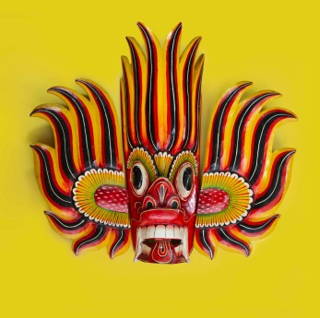1. Raksha Mask – Used to perform Raksha dances in KolamMaduwa. According to ancient chronicles, Sri Lanka was earlier ruled by a race of Rakshasas (devils) whose king was Ravana of the legend Ramayana. These Rakshasas were able to assume various forms which now the masks depict. There are 24 forms of Rakshasas but only a few are performed in Kolam dance. These masks include the cobra mask, the mask of a bird and the mask of the demon of death.

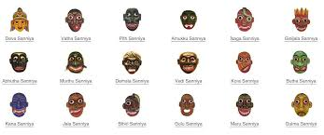2.Sanni Mask – These are used to treat illnesses while there are 18 sanni masks in use.

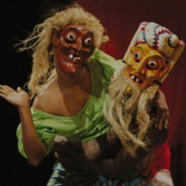3.Kolam Mask– This type is used mainly in dramas while popular kolam masks are Lenchina and Jasaya.

Ambalangoda Mask Museum is another attraction for those interested in this. This is a private museum. It’s name is AMBALANGODA ARIYAPALA MASK MUSEUM. <https://ariyapalamasksmuseum.com/> The entire venue consists of a mask museum, a mask making workshop and a mask showroom. The museum is quite educational with many exhibits related to the making of traditional and ancient Sri Lankan masks. All the masks on display and for sale are patiently hand-carved with intricate designs and painted in colorful colors that depict the traditional heritage passed down over the years.